**PROJECT REPORT ON CRICKET PLAYER ANALYSIS**

**INTRODUCTION**

Cricket is one of our country's most popular sports. Everyone, from newborns to the elderly, is well-versed in cricket. And we'll discover that cricket has been played on every street in India. Cricket is so popular that almost everyone plays it at least once in their lives.

Statistics such as average, best score, best wickets, and so on have been calculated and tracked for professional cricketers. And no one other than the professional players is in charge of calculating and tracking the metrics for the players. Our project assists people in calculating their own statistics.Our system takes their scores as inputs, calculates the statistics, and presents them.

**REQUIREMENTS**

***SOFTWARE REQUIREMENTS***

* Visual studio code(with c/c++ extensions and WSL)
* Multiple operating systems(install linux on windows using dual boot ,virtual machine etc)
* Unity test framework for testing(use unity.c,unity.h,unity_internal.h)
* You can download or clone unity test framework from (<https://github.com/ThrowTheSwitch/Unity>)

***HARDWARE REQUIREMENTS***

* Laptop with minimum RAM of 8GB and 1 TB of hard drive.

**BEHAVIOURAL DIAGRAMS**

***USE CASE DIAGRAM***

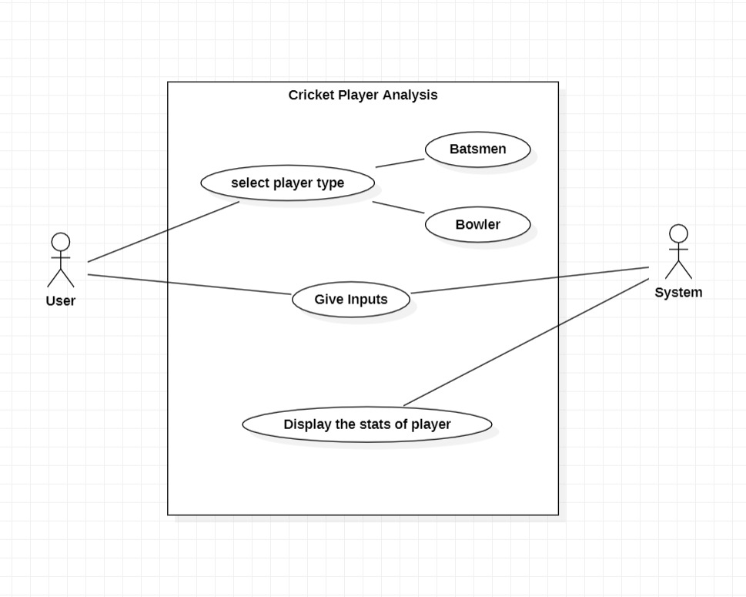

* A use case diagram can summarise the details of your system's users (also known as actors) and their interactions with the system in the Unified Modeling Language (UML). You'll need a collection of specialised symbols and connectors to construct one. A good use case diagram can assist your team in discussing and representing:
* Interactions between your system or application and people, organisations, or external systems
* Goals that your system or application assists those entities (sometimes referred to as actors) in achieving
* Your system's capabilities

***SEQUENCE DIAGRAM***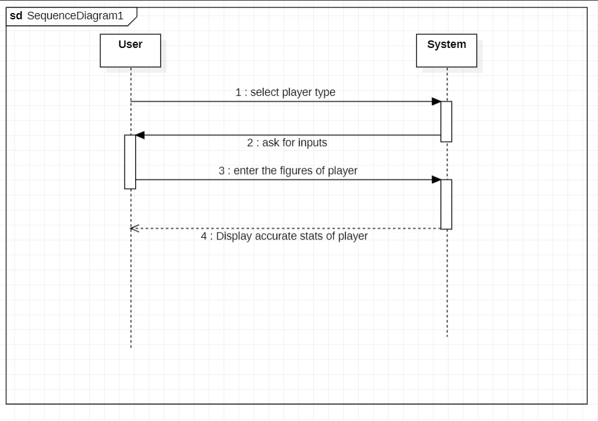

* A sequence diagram is a sort of interaction diagram that shows how a group of items interacts and in what order. Software engineers and business experts use these diagrams to understand the requirements for a new system or to describe an existing process. Event diagrams and event scenarios are other names for sequence diagrams.

**EXECUTION**

Our project consists of four files(batsmen.h,bowler.h,main.c,test.c).

To execute our project just run main.c and make sure batsmen.h,bowler.h and main.c are in same folder.

Test.c is for testing of our project .we have performed unit testing.

To perform unit testing we have to clone or download unity framework for(<https://github.com/ThrowTheSwitch/Unity>) .with the help of unity.c,unity.h,unity_internals.h and test.c we can perform unit testing on our project.